3 ways to instantly make your writing more conversational

Nicolas Cole
Apr 13, 2025
∙ Paid

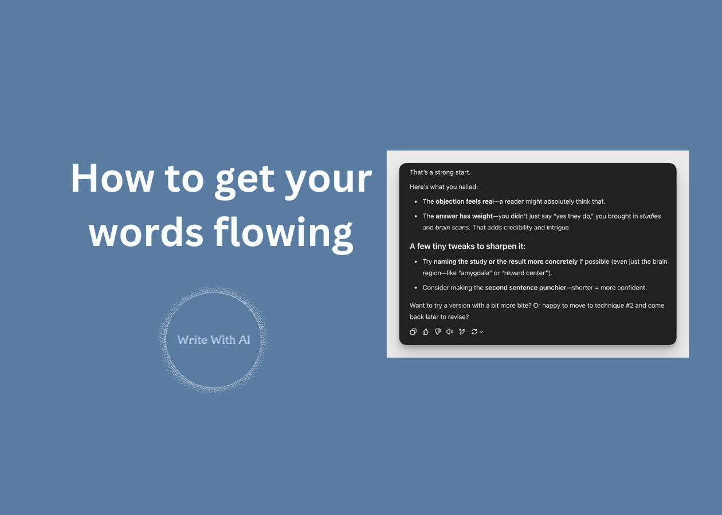

Good writing isn’t about big words or perfect grammar.
It’s about rhythm.
So, if your writing feels stiff or slow, it’s probably not what you’re saying—it’s how you’re saying it.
Here are 3 simple ways to instantly get your words flowing and make your writing more conversational.
Way #1: Raise objections before the reader does
If you tell your reader to “write daily,” their brain immediately goes: “Why? Do I have to write daily?”
And if you ignore that thought, you lose them.
Now look at this:
The easiest way to build a consistent writing habit:
Remember that every time you hit publish, you're leapfrogging millions of others who quit at that point in their journey.
It turns the monotonous, daily grind into a triumphant, daily win.
Can’t do it daily? Create a rhythm that works for you.
But be consistent.
See the difference?
You preempt the objection.
So instead of getting stuck, the reader nods and keeps moving. It’s like clearing rocks off the trail as they walk.
Then once you’ve removed the resistance, it’s time to pull them in.
Way #2: Ask targeted questions to create mental involvement
Most conversations start the same way:
With a question.
Which is exactly how conversational writing works too.
And the more specific your question, the more your reader has to answer it in their head. So, whenever you use this technique, make sure you narrow the context.
For example:
- Broad: “What would you do if you had more time?”
- Narrow: “What would you do with an extra 90 minutes each week?”
That’s the kind of question that makes your reader stop and answer it in their mind.
Now they’re in the conversation with you.
And with the next technique, you’re going to get them to lean in.
Way #3: Position your advice like it’s a cheat code
This one’s subtle.
When you share a tip, don’t frame it as “common sense.”
Frame it like a privilege. Something people shouldn’t know. Something you only figured out after experience, failure, or inside access.
Let me show you:
- Standard: “Use bullet points to break up long emails.”
- Privileged: “Here’s what I learned ghostwriting 200+ emails: If a sentence takes more than 6 seconds to read, break it into a bullet. You’ll double your read-through rate.”
See that?
Same advice. But one feels like a shortcut.
That’s it.
So, the next time you sit down to write:
- Raise and resolve one objection
- Ask a specific, visual question
- Frame one piece of advice as “privileged info”
You’ll sound more natural, more confident—and your writing will flow faster, too.
Want a little help practicing this?
Reading about these techniques is useful.
But doing them is how you build the skill.
That’s why I created a simple AI prompt you can use inside ChatGPT or Claude.
It works like a mini writing coach:
- Asks what you're writing about
- Walks you through each technique, one question at a time
- Gives feedback as you go
- Then helps you turn your responses into a polished paragraph
Here’s the full prompt:
Copy + paste this into ChatGPT (or Claude), then follow the instructions.
I want to write in a more conversational and engaging tone.

Act like a writing coach. Don’t write it for me—guide me through the process with one question at a time, give me feedback on each response, and help me improve as I go.

We’ll focus on 3 conversational techniques:

1. Raise and immediately answer an objection
2. Ask a targeted question that sparks mental involvement
3. Frame a piece of advice like it’s insider or privileged information

Start by asking:

“What are you writing about today?”

Once I answer, guide me through each of the 3 techniques with a single question and feedback loop.

At the end, help me combine all my responses into a polished opening paragraph or short-form post.

Let’s begin.
Try it on your next newsletter, thread, or post.
The more reps you get in, the more natural your voice becomes.

